WEEK 3 – PROCESS SCHEDULING SIMULATOR
Project Report
1. Objective
To design and implement a CPU scheduling simulator in C that simulates different CPU scheduling algorithms and analyzes their performance.
The simulator accepts process details, displays Gantt charts, calculates scheduling metrics, and evaluates CPU utilization.
2. Input Specification
The CPU Scheduling Simulator takes process details as input and executes the selected CPU scheduling algorithm. These inputs are used to calculate Waiting Time (WT), Turnaround Time (TAT), Response Time (RT), and their averages.
1. Number of Processes (n):
Specifies the total number of processes to be scheduled.
2. Process ID (PID):
A unique identifier assigned to each process, such as P1, P2, P3, and P4.
3. Arrival Time (AT):
The time at which a process enters the ready queue.
4. Burst Time (BT):
The total CPU execution time required by a process.
5. Priority:
Indicates the priority of a process. A smaller number represents a higher priority.
6. Time Quantum:
The fixed time slice allocated to each process in the Round Robin algorithm.
7. Scheduling Algorithm:
The user selects one of the six implemented algorithms:
- FCFS (First Come First Serve)
- SJF (Shortest Job First - Non-preemptive)
- Priority Scheduling (Non-preemptive)
- SRTF (Shortest Remaining Time First)
- Priority Scheduling (Preemptive)
- Round Robin (RR)

3. Performance Metrics
Completion Time (CT): The time when a process finishes execution.
Turnaround Time (TAT):
TAT = CT − AT
Waiting Time (WT):
WT = TAT − BT
Response Time (RT):
RT = First CPU Start Time − AT
Average Waiting Time:
Average WT = Total Waiting Time ÷ Number of Processes
Average Turnaround Time:
Average TAT = Total Turnaround Time ÷ Number of Processes
Average Response Time:
Average RT = Total Response Time ÷ Number of Processes
CPU Utilization:
CPU Utilization (%) = (CPU Busy Time ÷ Total Elapsed Time) × 100
CPU Busy Time = Total Elapsed Time − Total Idle Time
If the CPU is busy continuously from time 0 until all processes finish, CPU utilization is 100%. If idle intervals occur, include them in the calculation.
4. Test Case 1
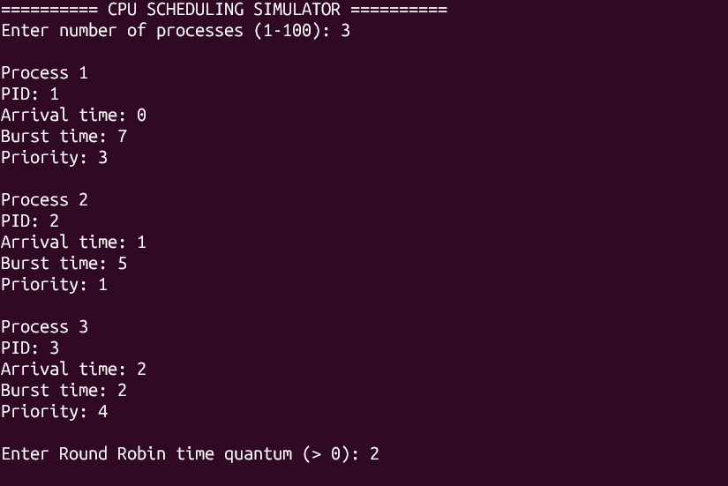
4.1 FCFS
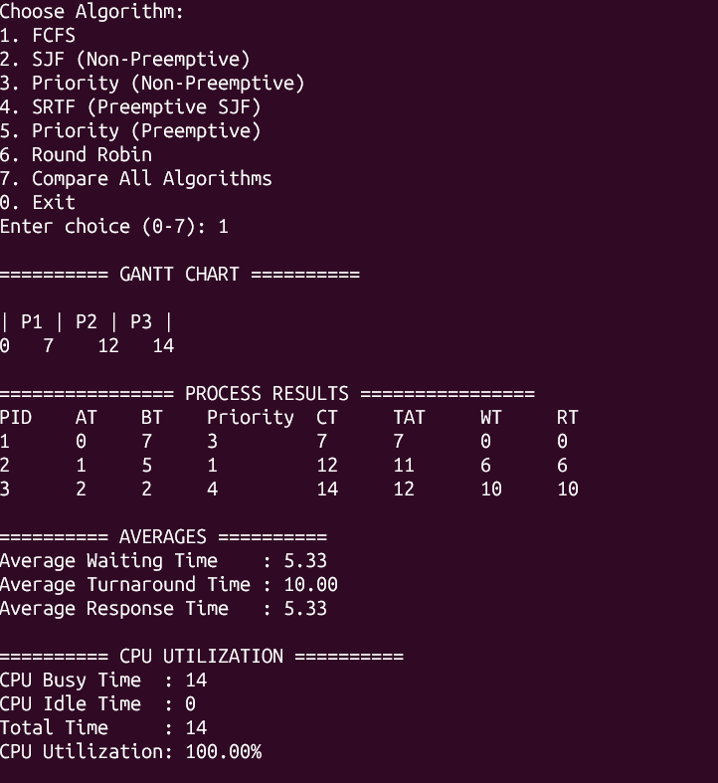

4.2 SJF Non-preemptive
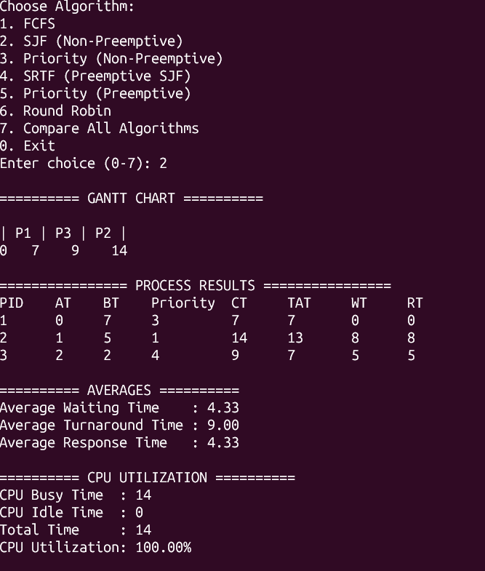
4.3 SJF Preemptive (SRTF)
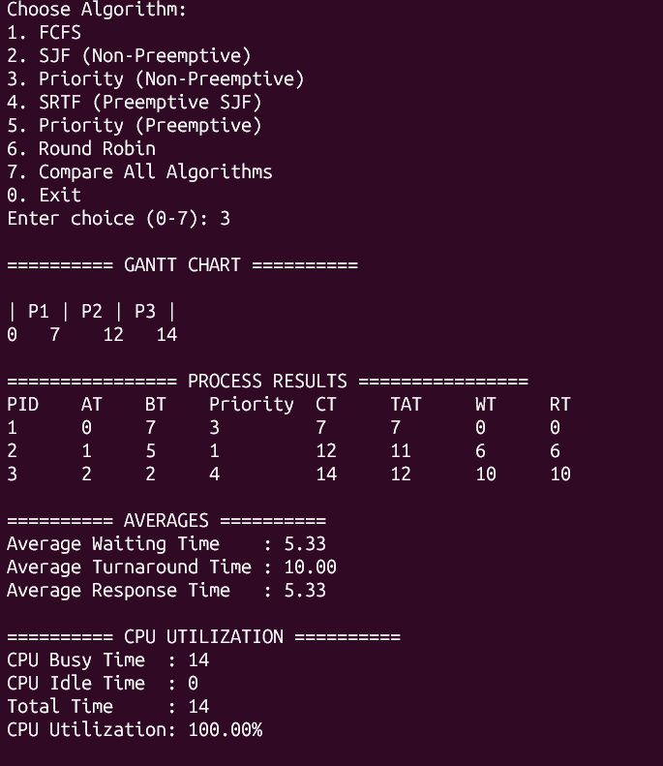
4.4 Priority Non-preemptive
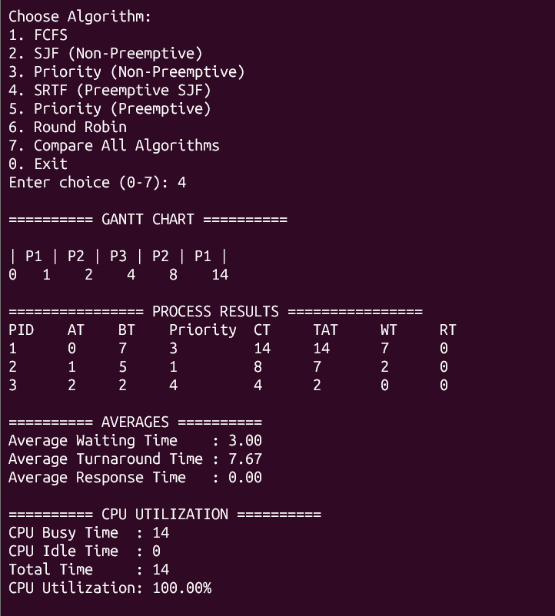
4.5 Priority Preemptive
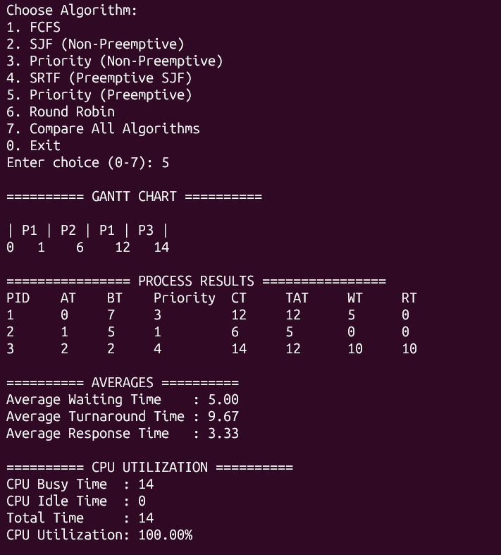

4.6 Round Robin
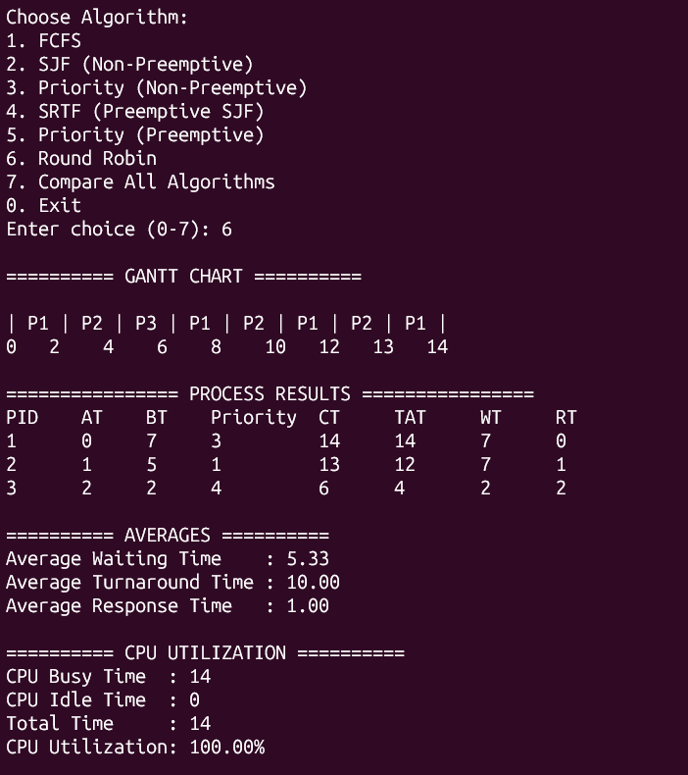
4.7 Compare All Algorithm
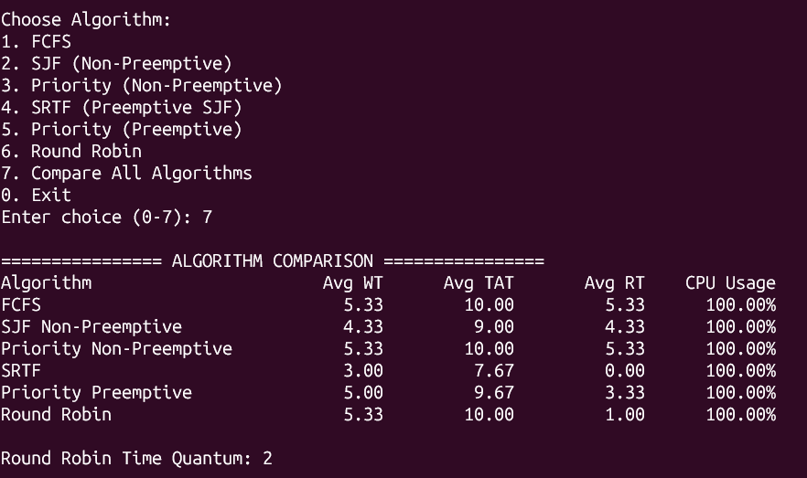
5. Test Case 2
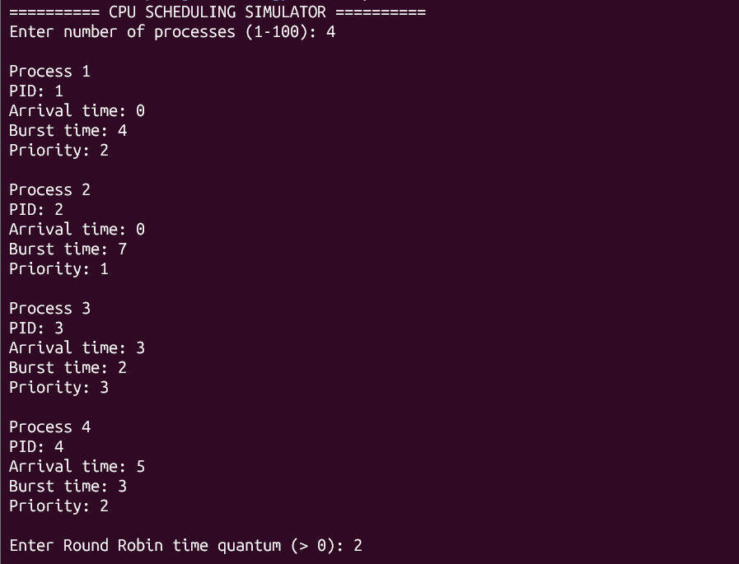
5.1 FCFS
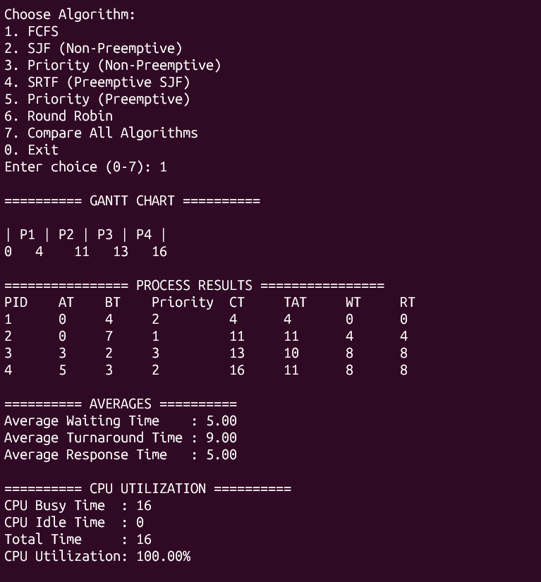
5.2 SJF Non-preemptive
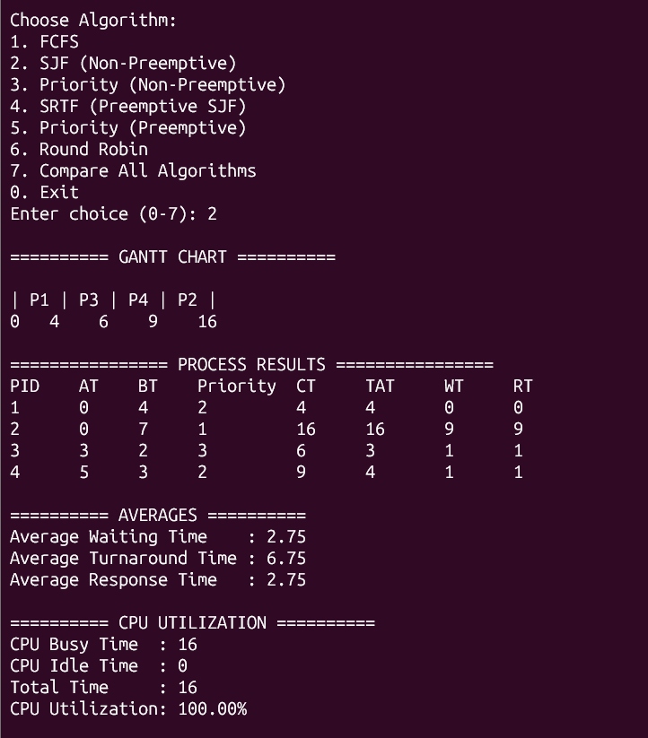
5.3 SJF Preemptive(SRTF)
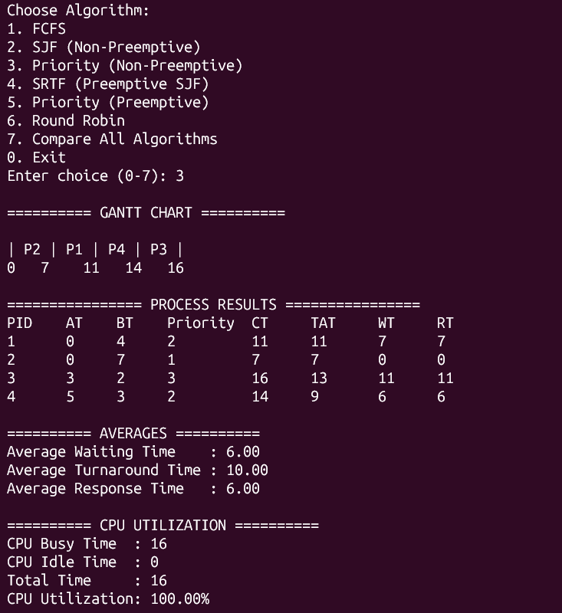
5.4 Priority Non-Preemptive
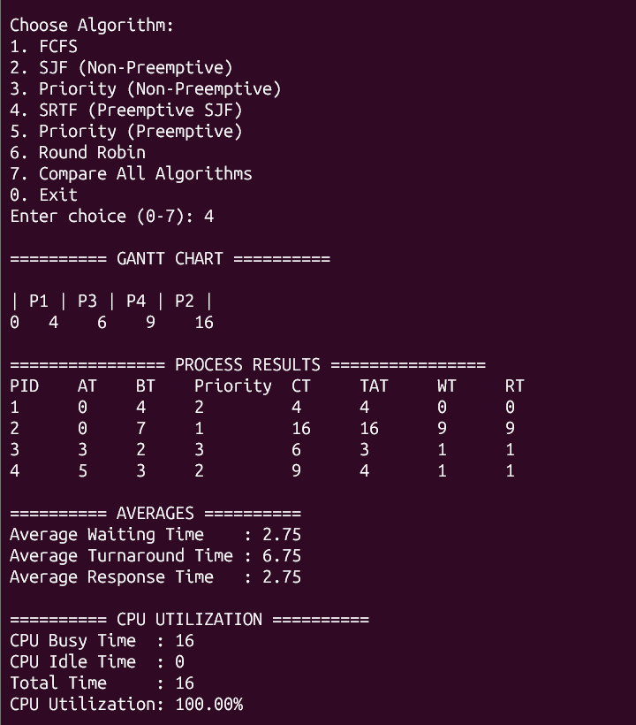
5.5 Priority Preemptive
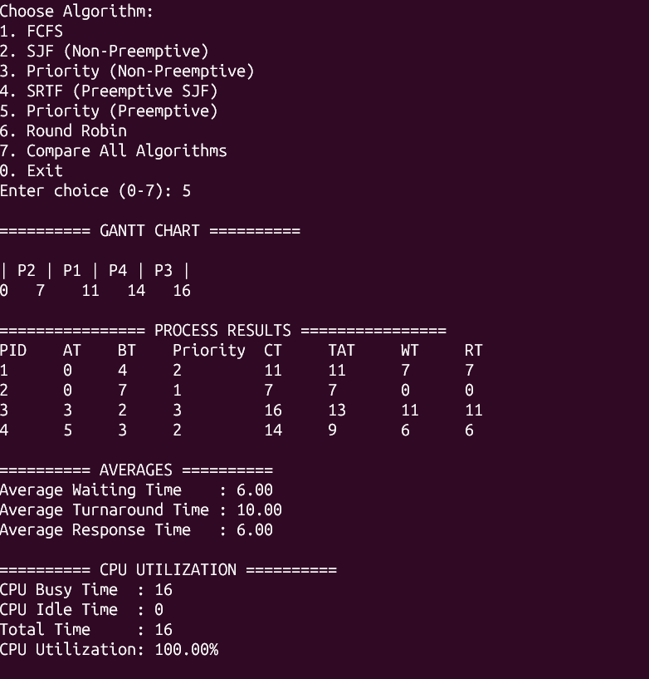
5.6 Round Robin
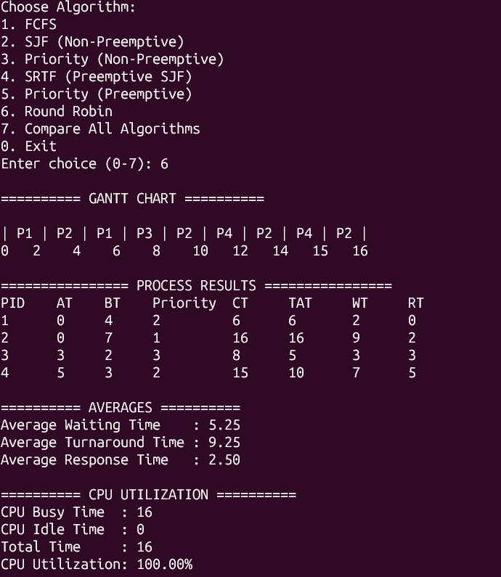
5.7 Compare All Algorithm
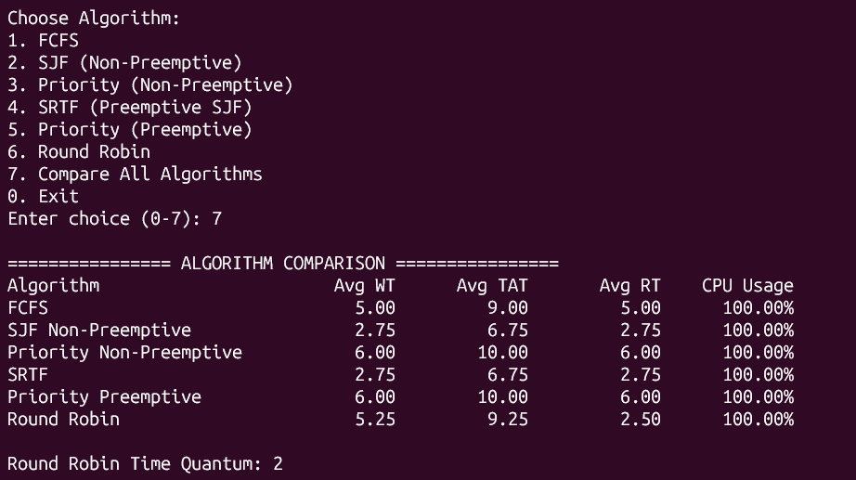
6. Test Case 3
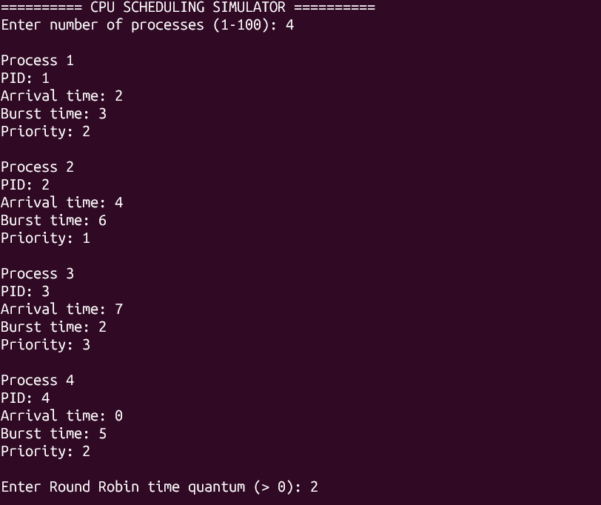
6.1 FCFS
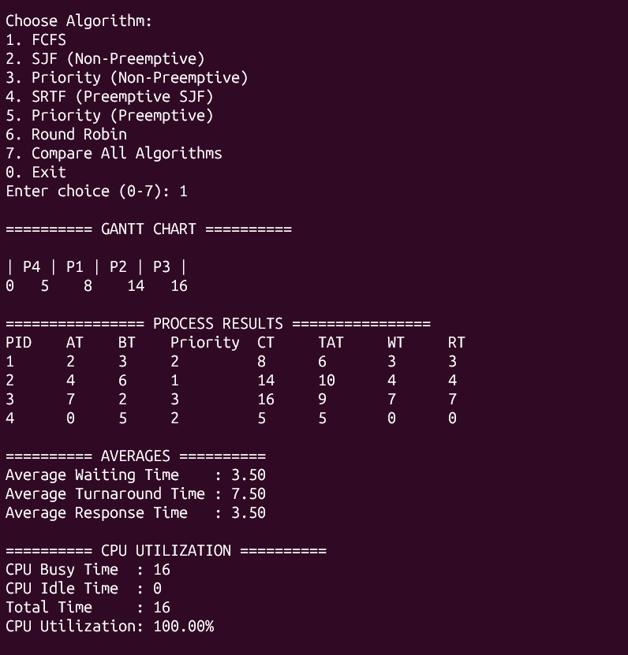
6.2 SJF Non-preemptive
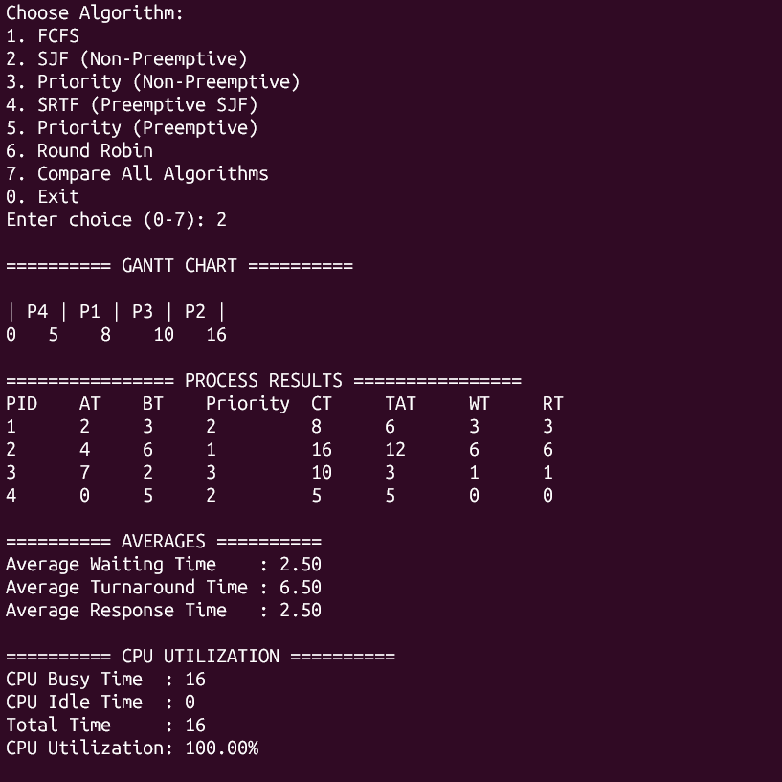
6.3 SJF Preemptive(SRTF)
6.4 Priority Non-preemptive
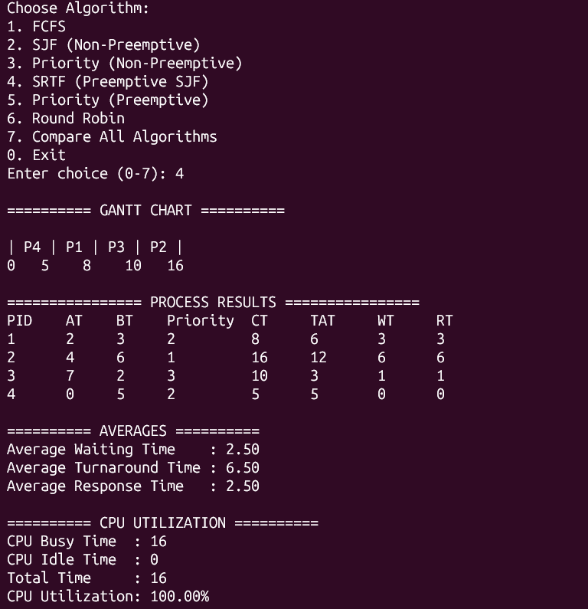
6.5 Priority Preemptive
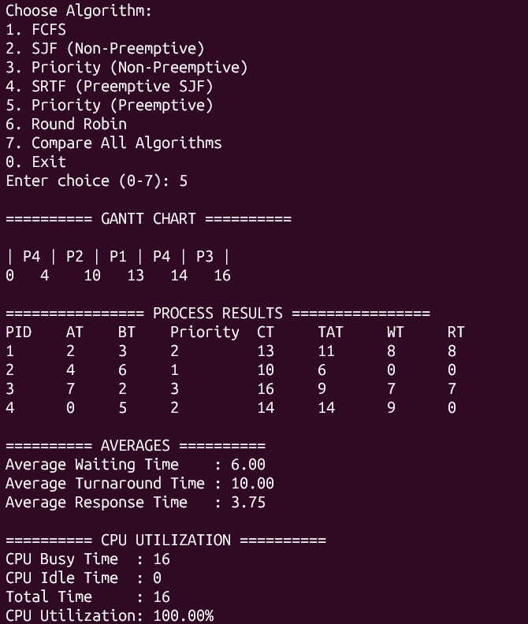
6.6 Round Robin
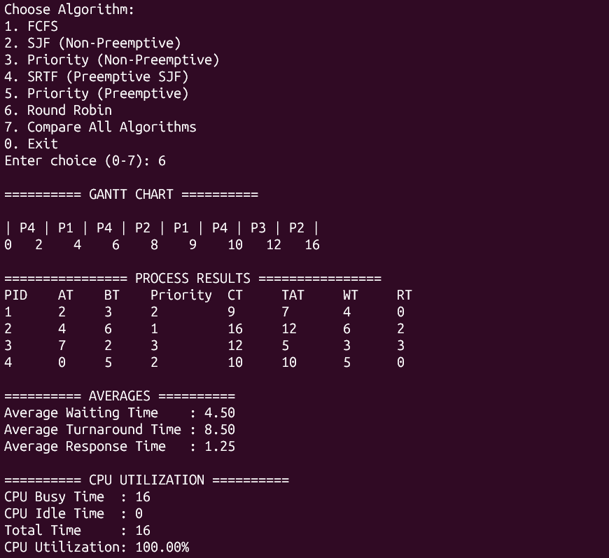
6.7 Compare All Algorithm
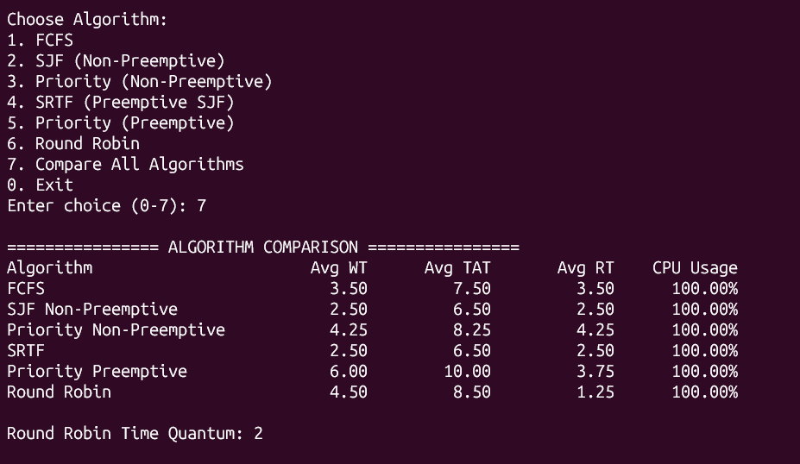
7. Performance Comparison
The CPU Scheduling Simulator compares six scheduling algorithms based on Average Waiting Time (WT), Average Turnaround Time (TAT), Average Response Time (RT), and CPU Utilization. Round Robin uses a time quantum of 2.
Test Case 1

Algorithm | Average WT | Average TAT | Average RT | CPU Utilization
FCFS | 5.33 | 10.00 | 5.33 | 100.00%
SJF Non-Preemptive | 4.33 | 9.00 | 4.33 | 100.00%
Priority Non-Preemptive | 5.33 | 10.00 | 5.33 | 100.00%
SRTF | 3.00 | 7.67 | 0.00 | 100.00%
Priority Preemptive | 5.00 | 9.67 | 3.33 | 100.00%
Round Robin | 5.33 | 10.00 | 1.00 | 100.00%

Test Case 2

Algorithm | Average WT | Average TAT | Average RT | CPU Utilization
FCFS | 5.00 | 9.00 | 5.00 | 100.00%
SJF Non-Preemptive | 2.75 | 6.75 | 2.75 | 100.00%
Priority Non-Preemptive | 6.00 | 10.00 | 6.00 | 100.00%
SRTF | 2.75 | 6.75 | 2.75 | 100.00%
Priority Preemptive | 6.00 | 10.00 | 6.00 | 100.00%
Round Robin | 5.25 | 9.25 | 2.50 | 100.00%
Test Case 3
Algorithm | Average WT | Average TAT | Average RT | CPU Utilization
FCFS | 3.50 | 7.50 | 3.50 | 100.00%
SJF Non-Preemptive | 2.50 | 6.50 | 2.50 | 100.00%
Priority Non-Preemptive | 6.00 | 10.00 | 6.00 | 100.00%
SRTF | 2.50 | 6.50 | 2.50 | 100.00%
Priority Preemptive | 6.00 | 10.00 | 3.75 | 100.00%
Round Robin | 4.50 | 8.50 | 1.25 | 100.00%

8 Performance Analysis
Based on the actual results obtained from the CPU Scheduling Simulator:
1. Lowest Average Waiting Time: SJF Non-Preemptive and SRTF achieved the lowest average waiting time of 2.50 units in Test Case 3.
2. Lowest Average Turnaround Time: SJF Non-Preemptive and SRTF achieved the lowest average turnaround time of 6.50 units in Test Case 3.
3. Lowest Average Response Time: SRTF achieved the lowest average response time of 0.00 units in Test Case 1.
4. CPU Utilization: The CPU utilization was 100% in all three test cases, indicating that the CPU remained busy throughout execution.
5. Effect of Preemption: Preemption allows a running process to be interrupted when another process needs the CPU according to the scheduling algorithm. SRTF reduced waiting and turnaround times in the tested cases.
6. Effect of Round Robin Time Quantum: A time quantum of 2 units allowed each process to receive CPU time in turns. It provided a response time of 1.00 unit in Test Case 1, 2.50 units in Test Case 2, and 1.25 units in Test Case 3.
9. Conclusion
The CPU Scheduling Simulator was successfully developed in C to implement six CPU scheduling algorithms. It accepts process details, displays Gantt charts, and calculates Waiting Time, Turnaround Time, Response Time, their averages, and CPU utilization.
Three test cases were used to compare the performance of the algorithms. The results showed that SJF and SRTF achieved lower waiting and turnaround times in the tested cases, while Round Robin provided CPU time to processes in turns. Overall, this project helped in understanding how different CPU scheduling algorithms work and how they affect process execution and system performance.

